**HAMILTON BASKETBALL ASSOCIATION INC.**

# **CLEARANCE FORM** (PLEASE PRINT IN BLOCK LETTERS)

Clearance form must be lodged with the HBA Competition Manager for processing, ***COMPLETE STEP 1 ONLY***.

Clearance must be approved before playing with a new club. **Clearances close after the completion of Round 3.**

**STEP 1.** PLAYER / CLUB Clearance details.

I hereby advise that I, *(Full Name)*,

of *(Address),* apply

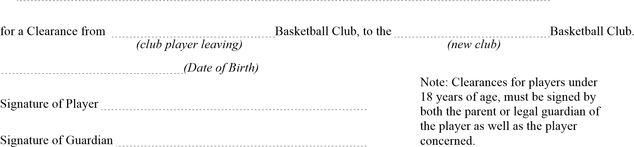

|  |  |
| --- | --- |
| Date clearance lodged with HBA |  |
| Club processing must be complete by this date or else, automatic clearance will be granted.  *(14 days from date clearance lodged with HBA)* | Signed HBA Senior Rep: |

**STEP 2.**

Full Name of Player:

 Club

*(new club)*

**OR**

(b) Has been refused a clearance from our club because:

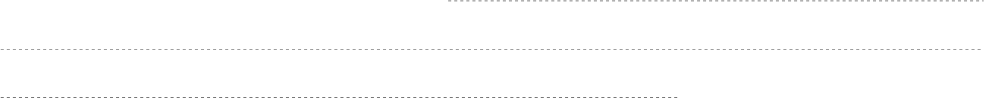

CLUB Secretary/Player Co-ordinator SIGNATURE:

*(club player leaving)*

**Office Use only:**

|  |  |  |  |
| --- | --- | --- | --- |
| **Name of applicant** | **Clearing Club** | **Accepting Club** |  |
|  |  |  |  |

Date received by HBA: Date New Club advised:

Due Date: (Automatic if not advised by this date)